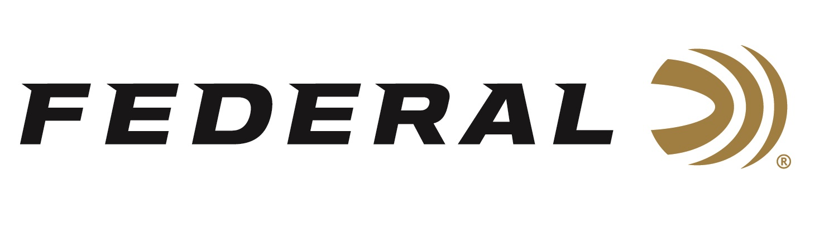

FOR IMMEDIATE RELEASE

Shooting for Glory Part #2 on “It’s Federal Season” Podcast

ANOKA, Minnesota – June 10, 2021 – The “It’s Federal Season” podcast wraps up its two-part series talking with members of USA Shooting as they prepare for the Olympics in Japan this summer. On this episode, Women’s Skeet team member Austen Smith and Women’s Trap team member Kayle Browning join the discussion as they prepare for the world’s largest competitive stage.

Episode #22 “Shooting for Glory Part #2”
https://www.federalpremium.com/this-is-federal/podcast/

Austen Smith, just a teenager from Texas, talks about her meteoric rise in the Women’s International Skeet division and about realizing her dream of making the Olympic team. “I was in shock at what I accomplished,” stated the nineteen-year-old Smith. “Besides competing, I’m looking forward to the opening ceremonies as it’s also my birthday,” said the first time Olympian.

Kayle Browning was an alternate on the 2012 team and has had success internationally at the Pan American Games as well as multiple World Cups. This once in a lifetime opportunity is still exciting to the veteran. “I can’t wait to get over to Japan and represent the United States to the best of my ability,” stated Browning. “We have great shotgun teams and look forward to bringing home a lot of medals for the U.S.A.”

“This is an exceptional discussion,” said Jason Nash, Vice President of Marketing for Federal Ammunition. “Both these competitors have great stories to tell and provide some background on their journeys, explain their games in great depth, and have some really good advice on how to improve your shooting.”

For this episode, besides listening on the Federal Premium website or Talk North podcast network, you can also subscribe to Federal Ammunition’s YouTube channel (https://www.youtube.com/user/federalpremiumammo) and tune in for the discussion.

Federal is the official shotshell ammunition sponsor and supplier of USA Shooting, a non-profit organization that promotes the shooting sports and prepares American athletes to bring home Olympic gold. Learn more about USA Shooting, Austen Smith and Kayle Browning at: http://www.usashooting.org.

Federal Ammunition can be found at dealers nationwide or purchased online direct from Federal. For more information on all products from Federal or to shop online, visit www.federalpremium.com.

Press Release Contact: JJ Reich
Senior Manager – Press Relations
E-mail: VistaPressroom@VistaOutdoor.com

About Federal Ammunition
Federal, headquartered in Anoka, MN, is a brand of Vista Outdoor Inc., an outdoor sports and recreation company. From humble beginnings nestled among the lakes and woods of Minnesota, Federal Ammunition has evolved into one of the world's largest producers of sporting ammunition. Beginning in 1922, founding president, Charles L. Horn, paved the way for our success. Today, Federal carries on Horn's vision for quality products and service with the next generation of outdoorsmen and women. We maintain our position as experts in the science of ammunition production. Every day we manufacture products to enhance our customers' shooting experience while partnering with the conservation organizations that protect and support our outdoor heritage. We offer thousands of options in our Federal Premium and Federal® lines-it's what makes us the most complete ammunition company in the business and provides our customers with a choice no matter their pursuit.

